**Multi-factor Strategy**

**Introduction:**

A multi-factor strategy is a stock-picking strategy by combining several factors for analysis. Factors are based on certain yield-related indicators (e.g. High, Close, Volumn...). It calculates a value and compares it to a specified threshold to go long or short a certain number of stocks. For example, we calculate the value of the indicator for each day and compare it to a threshold value endowed. We go long when the indicator value is greater than the threshold value and go short when it is less. The key to the multi-factor model is finding the relationship between factors and returns to make favorable trading decisions.

The key factor in our strategy is modified from the original Alpha-006. The basic logic of this factor is to go long when the stock price and volume are negatively correlated. We first calculate the correlation between the close price and the volume in the most recent *n* days, where *n* is the observed time. The higher the correlation, the closer the opening price and trading volume are to "rise-rise". As we need to find the circumstance of “rise-low” or “low-rise”, we multiply the factor by -1, resulting in the following equation:

$$α= -1*correlation\left(close, volume\right)$$

$$where observed time=most recent n days$$

**Data Analysis:**

Alpha-006 calculates the correlation between the close price and the corresponding volume. Thus, before applying this factor, we must first make sure that there exist some levels of correlation between the close price and volume on a particular day in the given data. In addition, as we introduce the parameter of observed time *n* in factor Alpha-006, we need to analyze how to choose the value of n based on the volatility of the given data.

***Part A – Prove of correlation between close price and volume***

We use the following R code to analyze the correlation between the given indicators in stock. Set stock 01 as an example.

*#Additional - Correlation Analysis*

Stock <- read.csv("01.csv", header=TRUE, sep=",", dec=".", fileEncoding="UTF-8-BOM")

*#Remove the date index*

Stock <- Stock[,-1]

*#Use of function rcorr()*

library(Hmisc)

Stock <- as.matrix(Stock)

rcorr(Stock)

*#Visualization*

library(PerformanceAnalytics)

chart.Correlation(Stock)

We get the display of correlation between indicators:

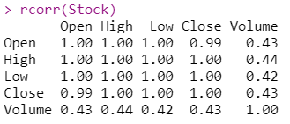

And a graph that clearly visualized the correlation:

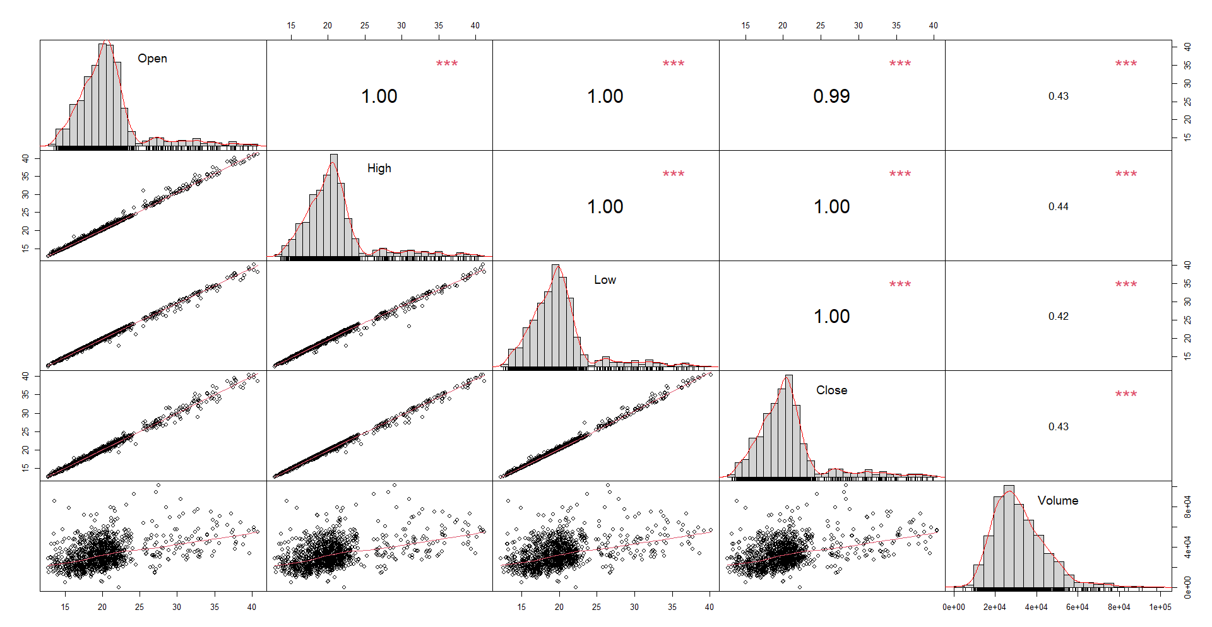

From the graph displayed, there exist high levels of correlation between indicators of stock 1. By conducting the same operations from stock 01 to stock 10, the correlation index of close price and volume are 0.4284853, 0.4394195, 0.0691163, 0.04081823, 0.1069442, -0.07284416, -0.0242775, 0.07110634, 0.4357325, -0.15527.

***Part B – The stocks’ volatilities and the observed period setting***

In the previous data analysis section, we used Python to calculate the volatilities of the given ten stocks and made a ranking. The result shows that stock no.1, 2 and 8 have the greatest fluctuation while stock no.6, 7 and 10 have the smallest.



For stocks with relatively stable prices, we tend to set the observed period longer so that the decision on a particular day can reference more previous day’s data, resulting in a more reliable trading decision. However, for the stocks with high volatility, the decision using a long-observed period will be greatly affected by fluctuations and become error-prone. Thus, our strategy with a long-observed period input is supposed to work well on stock 6,7,10 and badly on stock 1,2,8, and vice versa.

In this version of strategy design, we calculate the overall volatility of a stock and determine whether to set a long *n* or a short *n*. However, if there is one stock whose price is stable for a period, but suddenly turns to fluctuate in another period, The *n* we set based on the above data analysis will be inaccurate. This remains an unsolved weakness in our design. For the future improvement plan, this inaccuracy is assumed to be avoided if we could intelligently and intermittently analyze the volatility of each stock over time and set different *n* to different period.